Review
Anatomy of Cervical vertebrae:
The cervical vertebrae are made up of the first 7 vertebrae, referred to as C1-7. They are function to provide the mobility and stability to the head while connecting it to the relatively immobile thoracic spine. The cervical spine may be divided into two parts: upper and lower (Standring et al., 2016). (fig.1A, B, C)
Fig. (1): A, Anterior view of the cervical region of the vertebral column. (Standring et al., 2016).
Fig. (1): B, lateral view of the cervical region of the vertebral column. (Standring et al., 2016).

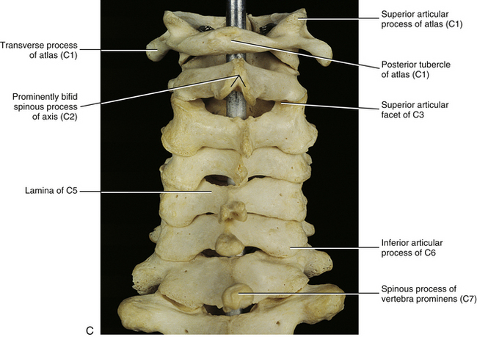
Fig. (1): C, posterior view of the cervical region of the vertebral column. (Standring et al., 2016).
Upper Cervical vertebrae: The upper cervical vertebrae consist of the atlas (C1) and the axis (C2).
Atlas (C1)
History and etymology:
The name "atlas" is derived from the Greek god who bore the world on his shoulders .The atlas is the first cervical vertebra, commonly called C1. It is an atypical cervical vertebra with unique features. It articulates with the dens of the axis and the occiput, respectively allowing rotation, flexion, extension and lateral flexion of the head.
(Lampignano& Kendrick, 2018).
Gross anatomy:
The atlas is composed of an anterior arch and a posterior arch, paired lateral masses, and paired transverse processes. It has the dens of the axis sit where a centrum (body) of a typical vertebra would be. The transverse ligament holds the dens of the axis against the anterior arch of the atlas so occupied by the dens. The posterior 2/3 contains the spinal cord, which occupies 1/3 of the total vertebral canal space (Standring et al., 2016).
The anterior Arch formed of anterior tubercle, which sits on the anterior aspect of the anterior arch and is the site of attachment of the anterior longitudinal ligament. Posterior facet for the dens sits on the posterior aspect of the anterior arch. The upper and the lower borders have the attachment of the anterior atlanto-occipital membrane and lateral parts of the anterior longitudinal ligament. The Posterior arch has 3/5 th of circumference of the ring, the posterior tubercle sits posteriorly to the posterior arch, is a rudimentary spinous process and attachment site for the ligamentum nuchae. The superior surface contains paired grooves for the C1 nerve and vertebral artery, sits just posterior to the lateral mass .The superior border has the attachment for the posterior atlanto-occipital membrane .The inferior border has the attachment for the ligamentum flava (Standring et al., 2016).
The lateral masses are paired and ovoid. The superior articular facet is kidney-shaped, concave and articulates with the occipital bone. The inferior articular facet is circular with a flat or slightly concave surface articulating with the lateral atlanto-axial joint. The medial surface is marked by vascular foramina and a tubercle for the attachment of the transverse ligament. The transverse processes are longer than all of the transverse processes of the cervical vertebrae except C7, typically covered by costal lamella. The transverse foramina contain the vertebral arteries. The anterior tubercle sometimes present on the anterior aspect of the transverse process (Standring et al., 2016). (fig.2)
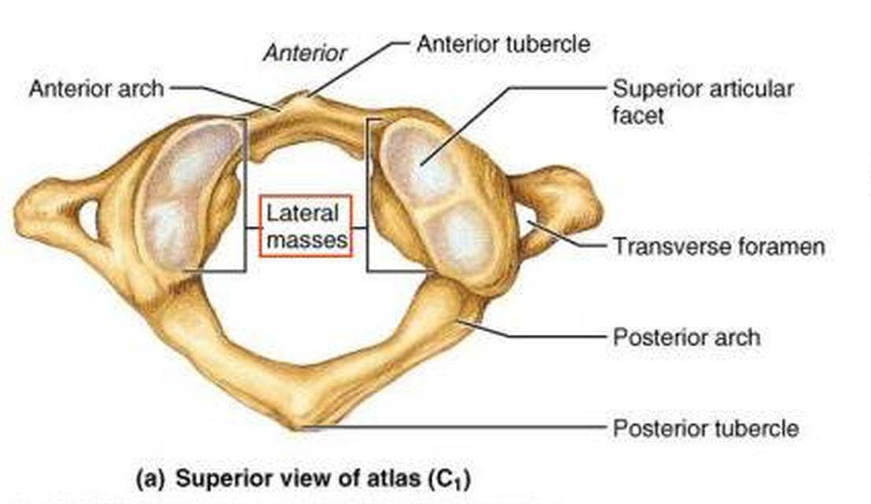
Fig. (2): The atlas, superior view (Standring et al., 2016).
Articulations:
Atlanto-occipital joint: synovial joint between the occipital condyle and concave facet of the lateral mass of the atlas. It is covered by a capsule and innervated by C1. This joint allows for flexion, extension and lateral flexion (lee et al., 2015).
Median atlanto-axial joint: synovial joint between the dens of the axis and the posterior aspect of the anterior arch of the atlas, allowing for the rotation of the head. The dens is held in place by the transverse ligament, with a bursa between the two (Sinnatamby, 2011).
Lateral atlanto-axial joint: synovial joint between the inferior articular facet of the atlas and the superior articular facet of the axis, which allows for the rotation of the head. A capsule innervated by the C2 nerve surrounds the joint (Sinnatamby, 2011).
Ligaments:
Transverse ligament is a strong band that runs posterior to the dens of the axis, holding it in place. Each end is attached to tubercles on the anterior arch of the atlas. The atlanto-axial ligaments attached from the lower border of the anterior arch of the atlas to front of the body of the axis. It provides tertiary support against ventral translation of the dens (Thompson, 2010).
Membrana tectoria inside the vertebral canal is a broad strong band representing the upward continuation of the posterior longitudinal ligament. Its superficial and deep laminae are both attached to the posterior surface of the axial body. The superficial lamina expands as it ascends to the upper surface of the basilar occipital bone, and attaches above the foramen magnum where it blends with the cranial dura mater. The deep lamina consists of a strong median band that ascends to the foramen magnum and two lateral bands that pass to and blend with the capsules of the atlanto-occipital joints as they reach the foramen magnum. The membrane is separated from the cruciform ligament of the atlas by a thin layer of loose areolar tissue and sometimes by a bursa (Standring et al., 2016).
Musculotendinous:
Anterior atlanto-occipital membrane attached to upper border of the anterior arch to the outer margins of foramen magnum. Posterior atlanto-occipital membrane attached to upper border of the posterior arch to the outer margins of foramen magnum. At each lateral margin, there is a gap for the passage of the C1 nerve and vertebral artery, which sometimes ossifies and becomes foramen (Benzel et al., 2012).
Longus colli muscle attached to the deep grooves on the anterior surface of the body. Levator scapulae muscle attached to the tip of the transverse processes .Splenius cervicis, Obliquus capitis superior and inferior muscles are attached to the transverse processes. Rectus capitis posterior minor muscle attached to tubercle on the posterior arch of the atlas (Benzel et al., 2012).
Axis (C2):
The axis is the second cervical vertebra, commonly called C2. It is an atypical cervical vertebra with unique features and important relations that make it easily recognizable. Its most prominent feature is the odontoid process, which is embryologically the body of the atlas. It plays an important role in rotation of the head with the majority of movement occurring around the dens and at the atlanto-axial joint (Lampignano& Kendrick, 2018).
Gross anatomy:
The axis is formed by a body with the attached dens, two lateral masses, a posterior neural arch (formed by the pedicle and a thick lamina), and a large spinous process which is commonly bifid. Anterior components of the axis are composed of the dens, which is conical in shape, body, lateral mass, and transverse process with foramina transversarium, superior articular facets and inferior articular facets (Standring et al., 2016). (Fig. 3)
Posterior elements of the axis are composed of pedicle, lamina and spinous process, which has several muscle attachments (semispinalis cervicis, rectus capitis posterior major, inferior oblique) (Xu et al., 2017).
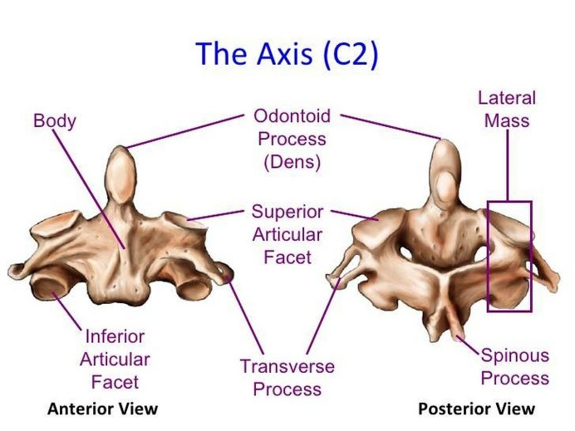
Fig. (3): Axis, anterior& posterior view (Standring et al., 2016).
Articulations:
Superior articular facet with inferior articular facet of C1.The dens articulates with the posterior aspect of the anterior arch of C1.The inferior articular facet articulates with the superior articular facet of C3 (Sinnatamby, 2011).
Ligament++s:
Important ligamentous structures are attached to the dens and play an important role in C1&C2 stability. The transverse ligament, which is the major portion of the cruciate ligament, arises from tubercles on the atlas and stretches across its anterior ring while holding the odontoid process (dens) against the anterior arch. A synovial cavity is located between the dens and the transverse process. This ligament allows rotation of the atlas on the dens and is responsible for stabilizing the cervical spine during flexion, extension and lateral bending. The transverse ligament is the most important ligament for preventing abnormal anterior translation (Standring et al., 2016).
Alar ligaments are thick cords, about 11 mm long, which pass horizontally and laterally from the longitudinally ovoid flattening on the posterolateral aspect of the apex of the dens to the roughened areas on the medial side of the occipital condyles. In most individuals, there is also an anteroinferior band, approximately 3 mm long, which inserts into the lateral mass of the atlas in front of the transverse ligament. Fibers occasionally pass from the dens to the anterior arch of the atlas. In addition, in some 10% of cases a continuous transverse band of fibers, the transverse occipital ligament passes between the occipital condyles immediately above the transverse ligament. The ligaments consist mainly of collagen fibers arranged in parallel (Standring et al., 2016).
Apical ligament of the dens fans out from the apex of the dens into the anterior margin of the foramen magnum between the alar ligaments, and represents the cranial continuation of the notochord and its sheath. It is separated for most of its extent from the anterior atlanto-occipital membrane and cruciform ligament by pads of fatty tissue, though it blends with their attachments at the foramen magnum and with the alar ligaments at the apex of the dens (Standring et al., 2016). (Fig. 4)
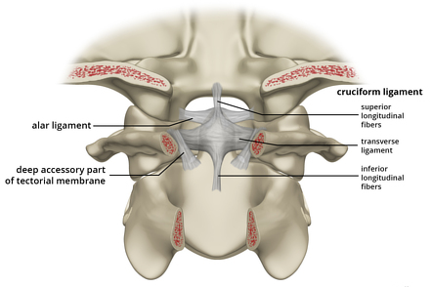
Fig. (4): Alar and Cruciform ligament anatomy (Standring et al., 2016).
Lower Cervical vertebrae
The lower cervical vertebrae are from C3 to C6, which have typical anatomy, and C7, which is a typical (Abrahams et al., 2013).
Gross anatomy:
Small, oval-sized vertebral bodies, relatively wide vertebral arch with large vertebral foramen, relatively long, bifid (except for C7) inferiorly pointing spinous processes, transverse foramina protecting the vertebral arteries and veins (Abrahams et al., 2013).
Osteology:
Anterior components of the typical cervical vertebra consisted of body, pedicle, anterior and posterior tubercle of the transverse process, intertubercular lamella of the transverse process and foramen of the transverse process. Posterior components of the typical cervical vertebra consisted of lamina, bifid spinous process, superior articular process and inferior articular process (Abrahams et al., 2013). (fig.5)
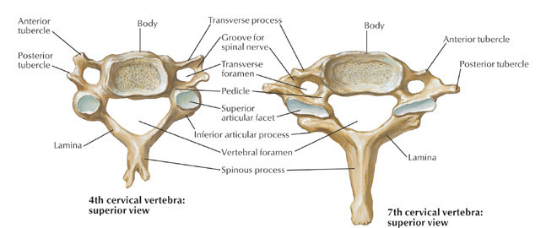
Fig. (5): Forth and Seventh cervical vertebra, superior view (Standring et al., 2016).
Articulations:
Intervertebral disc (superior and inferior): interposed between hyaline cartilage on the centrum of the vertebral bodies. The superior surface of the vertebra below curves upward to form a hyaline covered lip. The lip articulates with the inferior beveled surface of the vertebra above; this occurs bilaterally and thus the intervertebral foramen in cervical vertebrae is bordered anteriorly by both the cervical vertebrae from above and below (Lisle, 2012).
In the facet (zygapophyseal) joint the articular processes lie at the junction of pedicle and lamina, the articular surface can be viewed as a cylinder sliced obliquely. The upper facets face obliquely up and back. The lower facets face down and forward (Lisle, 2012).

Vertebra prominence (C7):
C7, also called vertebra prominence, is the seventh cervical vertebra and looks like the vertebrae from C3 to C6 but has some distinct features making it an atypical vertebrae. The name vertebra prominence arises from its long spinous process, which is easily palpable (Butler et al., 2012).
Gross anatomy:
C7 possesses the standard cervical vertebral features but has some distinct features: spinous process ends in a rounded tubercle and is not bifid. C7 transverse foramen are small, and do not transit the vertebral artery. C7 anterior tubercle is small, and is the site of attachment for scalenus pleuralis and suprapleural membrane. C8 nerve, which does not have an associated cervical vertebra, exits in the C7-T1 vertebral foramen below C7 (White et al., 2012) & (Grivas et al., 2013) (fig.5)
Ligaments:
The anterior longitudinal ligament is a strong band extending along the anterior surfaces of the vertebral bodies. It is thicker and narrower opposite vertebral bodies than at the levels of intervertebral symphyses. It extends from the basilar part of the occipital bone to the anterior tubercle of C1 and the front of the body of C2, and then continues caudally to the front of the upper sacrum. Its longitudinal fibers are strongly adherent to the intervertebral discs, hyaline cartilage end plates and margins of adjacent vertebral bodies and are loosely attached at intermediate levels of the bodies where the ligament fills their anterior concavities and flattening the vertebral profile (Standring et al., 2016).
The posterior longitudinal ligament lies on the posterior surfaces of the vertebral bodies in the vertebral canal, attached between the body of C2 and the sacrum and continuous with the membrana tectoria above. Its smooth, glistening fibers attached to intervertebral discs, hyaline cartilage end-plates and adjacent margins of vertebral bodies that are separated between attachments by basivertebral veins and the venous channels that drain them into anterior internal vertebral plexuses. At cervical levels, the ligament is broad and of uniform width, narrow over vertebral bodies and broad over discs (Kim et al., 2013).
The ligamenta flava connect laminae of adjacent vertebrae in the vertebral canal. Their attachments extend from facet joint capsules to the point where laminae fuse to form spines. Here their posterior margins meet and are partially united; the intervals between them admit veins that connect the internal and posterior external vertebral venous plexuses. The ligaments are thin, broad and long in the cervical region (Cramer& Darby, 2017).
Interspinous ligaments connect the spinous processes of adjacent vertebrae and extend ventrally as far as the ligamentum flavum and dorsally to the supraspinous ligament. The interspinous ligaments are not evident at cervical levels where they are represented by the median septum of the ligamentum nuchae as it passes between the cervical spinous processes (Cramer& Darby, 2017).
The supraspinous ligament is a strong, fibrous cord that connects the tips of spinous processes from C7 to L3 or L4.the nuchal ligament is the continuation of the supraspinous ligament. It attaches to the tips of the spinous processes from C1-C7 and provides the proximal attachment for the rhomboids and trapezius muscles. Intertransverse ligaments run between adjacent transverse processes. At cervical levels, they consist of a few and irregular fibers that are largely replaced by intertransverse muscles (Standring et al., 2016).
Spinal canal:
In the cervical spine, its outline is oval in the transverse plane and the average anteroposterior diameter is 17 mm, although this varies with movement: flexion increases it and extension decreases it. During extension, there is a backward movement of the upper vertebra in relation to the lower because of the obliquity of the facet joints. As the anteroposterior diameter of the spinal cord at mid cervical level is about 10 mm, there is however a large margin of safety (Wong & Transfeldt, 2015).
Intervertebral foramen:
The intervertebral foramen lies between adjacent pedicles and through it, the spinal nerve emerges from the spinal canal. The foramen continues across the bifid transverse process and is orientated anterolaterally 45° and anterocaudally 15°. The anterior border is the uncinate process and vertebral body and the articular facet is posterior. The diameter of the foramen is reduced during a combined movement of extension and ipsilateral rotation (Cramer& Darby, 2017).
Innervation of the cervical vertebrae:
The anterior primary rami and their branches innervate that part of the cervical spine, which lies anterior to the plane of the intervertebral foramina. The posterior aspect of the spine is innervated from the posterior primary rami (Cramer& Darby, 2017).
Blood supply of the cervical vertebrae:
The main blood supply of the cervical vertebrae and related structures is from the vertebral arteries, which originate from the subclavian arteries and finally join to form the basilar artery. During their course, they give off branches to the spine and to the spinal cord (anterior and posterior spinal arteries). The vertebrobasilar system is a ‘closed’ circuit, starting below in the subclavian arteries and ending above in the arterial circle of Willis. The vertebral arteries run parallel on both sides of the spinal column through the canal formed by the successive transverse foramina, and are the main blood supply for the cervical spine, the spinal cord and the brainstem. Between the axis and the atlas, the arteries curve backwards and outwards and run over the posterior arch of the atlas. They curve upwards again and run cranially. Inside the skull, they join to form the basilar artery, which then splits into a left and right posterior cerebral artery. These arteries communicate with the internal carotid artery from which the anterior cerebral arteries branch off (Standring et al., 2016).
Lymphatic drainage of the cervical vertebrae:
The cervical vertebral column drains to deep cervical lymph nodes (Standring et al., 2016).
Applied Anatomy:
Cervical rib is a supernumerary or accessory rib arising from the seventh cervical vertebra. They occur in ~0.5% of the population, and are more common in females. Although cervical ribs are usually asymptomatic, they are the most important anatomic rib variant clinically because they can cause thoracic outlet syndrome by compression of the brachial plexus or subclavian vessels (kim et al., 2013).

Embryology and Development
Of the Cervical Vertebrae
Embryology of cervical vertebrae:
Human development in utero (gestation) has been divided into the embryonic period and the fetal period. The embryonic period is considered the time from fertilization to the end of 8th week of gestation. The remainder of gestation is called the fetal period. By the end of the embryonic period, all the major organ systems have been established and the basic body plan is complete. In the early embryo, the mesoderm on either side of the neural tube (paraxial mesoderm) differentiates into paired blocks of cells called somites. The somites further differentiate into sclerotomes and dermatomes. The sclerotomal cells collect segmentally at the embryonic midline, surrounding the neural tube and the notochord and form the precursors of the vertebral arch and vertebral body (Alexander et al., 2010). (fig.6)
Fig. (6): Ventromedial cells of the sclerotome migrate toward the midline of the embryo to surround the neural tube and the notochord. There they form the precursors of the vertebral arch and vertebral body. (Alexander et al; 2010)
The sclerotomal cells also begin to separate into a cranial portion and a caudal portion. The cranial portion of each sclerotome recombines with the caudal portion of the directly superior sclerotome in a resegmentation process known as metameric shift. After the metameric shift, spinal nerves, which originally left the neural tube to go to the center of the sclerotome, are able to pass between the precartilaginous vertebral bodies to innervate the segmentation myotomes (Alexander et al., 2010). (fig.7)
Fig.(7): Vertebral morphogenesis; each vertebral sclerotome splits into a cranial and a caudal portion which recombine with the superior and inferior sclerotome, permitting the segmental spinal nerves to grow out and to innervate the myotome derivatives. (Alexander et al., 2010).
The atlas and axis form via a mechanism different from that governing the formation of the other vertebral bodies. Part of the first cervical sclerotome plus the cranial portion of the second cervical sclerotome contributes cells, forming the odontoid process and the arch of the atlas. In the cervical region, the eight cervical somites generate seven cervical vertebrae because the cranial portion of the first cervical sclerotome contributes to the formation of the occiput and the caudal portion of the eighth cervical sclerotome contributes to T1. In this way, the eight cervical spinal nerves become associated with seven cervical vertebrae (Sadler, 2015).
The first cervical spinal nerve passes between the base of the skull and the first cervical vertebra. The eighth cervical nerve exits below the seventh cervical vertebra and above the first thoracic vertebra. The remainder of the nerve roots exit below their corresponding vertebral bodies (Brand, 2008).
The cervical spine has 8 nerves as a result of the resegmentation of the sclerotome. The cranial portion of the first cervical sclerotome combines with the fourth occipital sclerotome to contribute to the base of the skull whereas the eighth cranial somite contributes to C7 and T1.The intervertebral disks form in the area between the segmented vertebral bodies after the split of the sclerotomes. The nucleus pulposus originates from cells of the notochord whereas the annulus fibrosis originates from the sclerotomal cell (Brand, 2008).
Development of the Cervical Vertebrae:
The first two cervical vertebrae are unique in their development. The atlas is formed by three primary ossification sites: the anterior arch and the two neural arches, which surround the anterior arch and fuse later in life to form the posterior arch. The anterior arch is ossified in only 20% of cases at birth and becomes visible as an ossification center by 1 year of age. The neural arches appear in the 7th fetal week. The anterior arch fuses with the neural arches by 7 years of age before this, “nonfusion” may be mistaken for a fracture. The neural arches fuse posteriorly by 3 years of age (Akbarnia et al., 2016). (fig. 8)
Fig. (8): An axial computed tomographic (CT) scan through C1 in an infant show the ossification centers of C1 with open synchondrosis (arrows). Note the segmented tip of the dens (arrowhead). (Akbarnia et al., 2016)
The axis has the most complex and unique development of all vertebrae. There are four ossification centers at birth: one for each neural arch, one for the body and one for the odontoid process. The odontoid process forms in utero from two separate ossification centers that fuse in the midline by the 7th fetal month. A secondary ossification center appears at the apex of the odontoid process (os terminal) between 3 and 6 years of age and fuses by age 12 years. The body of C2 fuses with the odontoid process by 3–6 years of age. This fusion line (subdental synchondrosis) or the remnant of the cartilaginous synchondrosis can be seen until age 11 years and may be confused with a fracture. The neural arches fuse posteriorly by 2–3 years of age and with the body of the odontoid process between 3 and 6 years of age (Cramer& Darby, 2017). (fig.9)
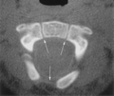
Fig.(9): An axial CT scan through C2 in an infant show the ossification centers of C2 with open synchondrosis (arrows) (Cramer& Darby, 2017).
C3 through C7 can be discussed as a unit because they exhibit the same developmental pattern. Three ossification sites are present; the body arises from a single ossification site and the two neural arches. The three primary ossification centres start appearing at 9th week in utero. The neural arches fuse posteriorly by age 2–3 years and the body fuses with the neural arches between 3 and 6 years of age. Additionally, secondary ossification centers may be seen at the tips of the transverse processes and spinous processes that may persist until early in the 3rd decade of life and simulate fractures. Secondary ossification centers can also appear at the superior and inferior aspects of the cervical vertebral bodies and remain unfused until early adulthood
(Cramer& Darby, 2017). (fig.10)
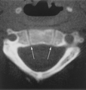
Fig. (10): An axial CT scan through C3 in an infant show the ossification centers of C3 with open synchondrosis (arrows) (Cramer& Darby, 2017).
Congenital Anomalies of Cervical vertebra:
Congenital anomalies of the cervical spine, though rare, are worthy of attention because neurologic compromise from instability or stenosis may be prevented with early recognition and careful management of persons who are at risk. Congenital anomalies range in severity from those that are benign and asymptomatic to anomalies that can potentially cause fatal instability. Many anomalies are not discovered until a complication occurs. Anomalies of the occipitocervical junction often are not detected until late childhood or adolescence and some remain hidden well into adult life. Other anomalies of the cervical spine, although recognized in early life may not become clinically significant until adulthood. Although they are rare, it is important that such anomalies be recognized in order to prevent catastrophic paralysis as a result of sports participation or manipulation during anesthesia (Bouchoucha et al., 2011).

Basilar impression:
Basilar impression (or invagination) is a deformity of the bones of the base of the skull at the margin of the foramen magnum. The floor of the skull appears to be indented by the upper cervical spine. With basilar impression, the upper cervical spine encroaches on the brainstem and spinal cord as the base of the skull is displaced toward the cranial vault. This increases the risk of neurologic damage from injury, circulatory embarrassment or impairment of the cerebrospinal fluid (CSF) flow (Mourad et al., 2016).
Occipitocervical synostosis:
A partial or complete congenital union between the atlas and the base of the occiput characterizes Occipitocervical synostosis. The condition is also known as occipitalization of the atlas and assimilation of the atlas into the occipital bone. Occipitocervical synostosis, basilar impression and odontoid anomalies are the most common developmental malformations of the occipitocervical junction. Incidence ranges from 1.4-2.5 per 1000 children and the two sexes are affected in equal numbers. The age range of patients presenting with this anomaly is reported to be 8-52 years. Some patients develop symptoms following mild trauma while others remain entirely asymptomatic throughout life (Bouchoucha et al., 2011).
Odontoid anomalies:
Anomalies of the odontoid process or dens may range from complete absence (aplasia) of this feature to partial absence (hypoplasia) of the process to separation of the dens from the axis (a condition known as os odontoideum). These anomalies can lead to atlantoaxial instability and may cause neurologic deficit and even death. The frequency of these anomalies is unknown and like many anomalies that may be asymptomatic, they probably are more common than is recognized. Aplasia is extremely rare, hypoplasia and os odontoideum are reported infrequently and can be considered rare. Odontoid anomalies in association with ligamentous laxity producing atlantoaxial instability, are more common in patients with Down syndrome, Morquio syndrome, Klippel-Feil syndrome and some skeletal dysplasia (Yang et al., 2016) (fig.11)
Fig. (11): Gradations of the odontoid process's appearance (Yang et al., 2016)
Klippel-Feil syndrome:
Klippel-Feil syndrome is uncommon. As currently used, the term refers to all patients with congenital fusion of the cervical vertebrae, whether it involves two segments, congenital block vertebrae or the entire cervical spine. Congenital cervical fusion is the result of failure of normal segmentation of the cervical somites during weeks 3-8 of life. With the exception of a few patients in whom this condition is inherited, the etiology is undetermined. The frequency is about 1 in 42,000 births and 65% of patients are female (Akbarnia et al., 2016). (fig.12)

Fig. (12): Klippel-Feil syndrome with congenital fusion of the entire cervical spine (Akbarnia et al., 2016).
Syndromes Associated with Congenital Spinal Deformity
Down syndrome:
Down syndrome (trisomy 21 syndrome) is characterized by hypotonia, a flat facies, slanted palpebral fissures and small ears. Incomplete fusion of vertebral arches of the lower spine occurs in 37% of persons with Down syndrome, Atlantoaxial instability in 12%, abnormal odontoid process in 6%, and a hypoplastic posterior C1 arch in 26%.Any child with Down syndrome who develops changes in bowel or bladder function or in neck posturing or who loses ambulatory skills should be evaluated carefully with plain radiographs of the cervical spine. Most patients develop symptoms when they are younger than 10 years, when the ligamentous laxity is most severe (Yang et al., 2016).
Cervico-oculo-acoustic syndrome:
Cervico-oculo-acoustic syndrome (Wildervanck syndrome) described in 1952. This disorder is characterized by Klippel-Feil anomaly (fusion of two or more cervical vertebrae and sometimes of thoracic vertebrae), abducens paralysis with retracted globs and sensorineural deafness, torticollis and Sprengel deformity (Karol et al., 2008).
MURCS association:
MURCS association (mullerian duct, renal, and cervical vertebral defects) described in 1979. It consists of a nonrandom association of müllerian duct aplasia, renal aplasia and cervicothoracic somite dysplasia. The incidence of cervicothoracic vertebral defects especially from C5-T1 is 80%. Other abnormalities may include Sprengel deformity, upper limb defects, and moderately frequent rib anomalies (Akbarnia et al., 2016).

Radiographic features
Plain radiograph:
Lateral radiograph cervical spine in which the patient is supine, this view will allow for all 7 vertebrae to be seen. Swimmers view is another lateral view where the patient will have one arm up and one down provides views of the cervicothoracic junction. AP open mouth view allows for assessment of C1 and C2 alignment and the dens. Oblique view for facet joints and intervertebral foramina. The odontoid process and atlanto-axial joint are best appreciated in an AP open mouth view. Soft tissue contours are visible on lateral views (Abrahams et al., 2013). (fig.13)
Fig. (13): Lateral radiograph of cervical vertebrae showing all 7 vertebrae (Abrahams et al., 2013).
Transoral AP view best appreciates the atlanto-axial joint. (Kang et al; 2016) (fig:14).
Fig. (14): AP open mouth view of cervical vertebrae (Kang et al; 2016).
The axial CT section at C3 passes through the hyoid bone and epiglottis, just below the mandible. The projecting contour anteriorly indicates that the plane is close to the mandible, the mylohyoid and anterior belly of the digastric muscles and the submandibular glands are visible. This is also at the level of the division of the common carotid artery into its internal and external branch (Netter, 2014). (fig. 15)
Fig. (15): Axial CT through C3 and the Hyoid Bone (Netter, 2014).
The Larynx is the most prominent structure at the level of C5. In this axial CT, the section is through the true vocal folds and thyroid cartilage of the larynx. It is above the level of the cricoid cartilage. Between the larynx and C5 vertebra is the carotid sheath containing the internal jugular vein and common carotid artery. Note that the left internal jugular vein is much larger than the right. The sternocleidomastoid and trapezius muscles define the contour of the neck at all levels (Netter, 2014). (fig. 16)

Fig. (16): Axial CT through C5 and the Larynx is the most prominent structure at the level of C5 (Netter, 2014).
The axial (transverse) section of the neck at the level of the seventh cervical vertebra (C7) is through the thyroid gland (Netter, 2014). (fig. 17)
Fig. (17): Axial (transverse) section of the neck at the level of the seventh cervical vertebra (C7) is through the thyroid gland (A and B). CT (A) is used for evaluation of the neck because of rapid scanning that can be obtained during a breath hold. (B) Cross section through C7 and the thyroid gland (Netter, 2014).

